Instructions for VM Setup
Table of Contents
Task 1: Login to Azure Portal on the Web 1
Task 2: Login to Azure using the CLI 1
Task 3: Infrastructure Setup to Create Environment 3
Task 4: Connect to Virtual Machine over SSH 4
Task 5: Connect to SFTP for transferring jar file to Virtual Machine 5
Task 5.1: Manually transferring jar file to Virtual Machine 5
Task 5.2: (Other method) Use bash script to transfer jar file to Virtual Machine 6
Task 6: Run Jar File on Virtual Machine 7
Task 6: Access website via Web Browser 7
Task 7: Teardown file to remove environment 8

Task 1: Login to Azure Portal on the Web
Use your required credentials to log into Azure on the Web Browser.

Task 2: Login to Azure using the CLI
Open Windows PowerShell terminal on your PC by using the search bar
Run the command:
az login
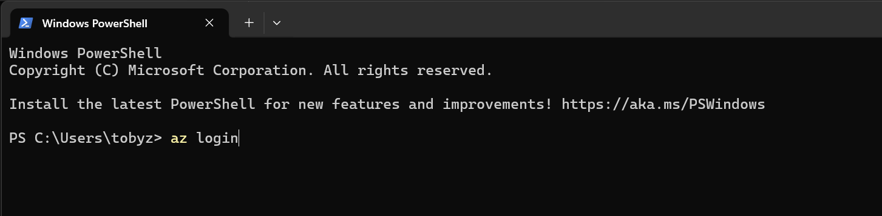
Figure 1 - az login command
Use the DKIT login and follow the steps for 2 factor authentication:
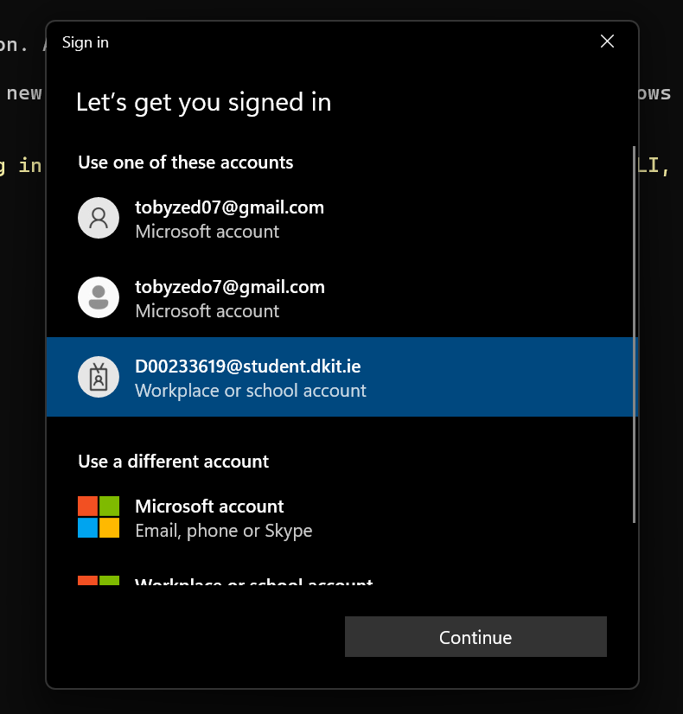
Figure 2 - Choose account and login
When asked about subscription, type 1 and press enter: 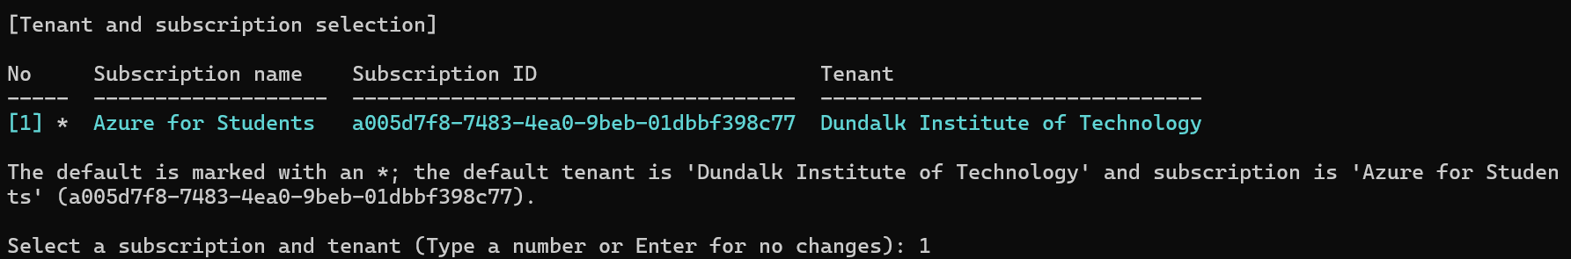
Figure 3 - Subscription type

Run the command:
az account show
It verifies you are logged into Azure, and you will see something like this:
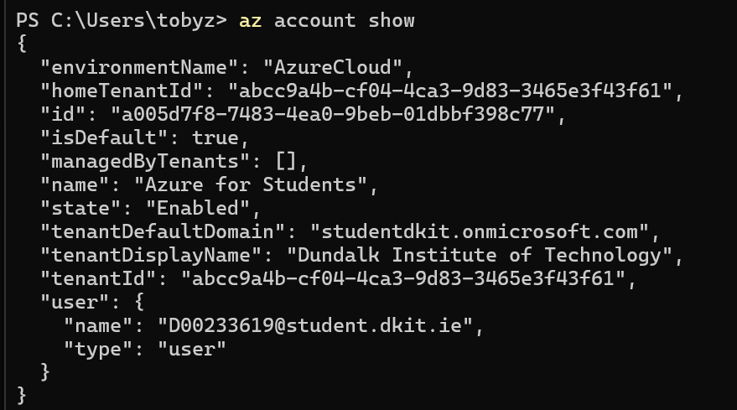
Figure 4 - Verify Account Login

Task 3: Infrastructure Setup to Create Environment

Download and Unzip folder with all necessary scripts for the VM Setup
On Windows terminal, use this command to go into project folder with all the necessary scripts:
Command for if on Desktop:
cd Desktop\CloudArchCA2
Command for if on Downloads:
cd Downloads\CloudArchCA2

Command to go into Project folder:
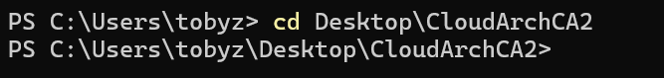
Figure 5 - Command to go into folder
Run the setup.ps1 file to create Virtual Machine environment, it also runs the vm_init.yml script for when the Virtual Machine runs for the first time.
Use command:
./setup.ps1
Running the setup.p1 script for VM environment:
Figure 6 - Running Setup File for VM environment

Enter command to check existence of environment made:
az vm show --resource-group ca1_rg --name ca1-VM --show-detail
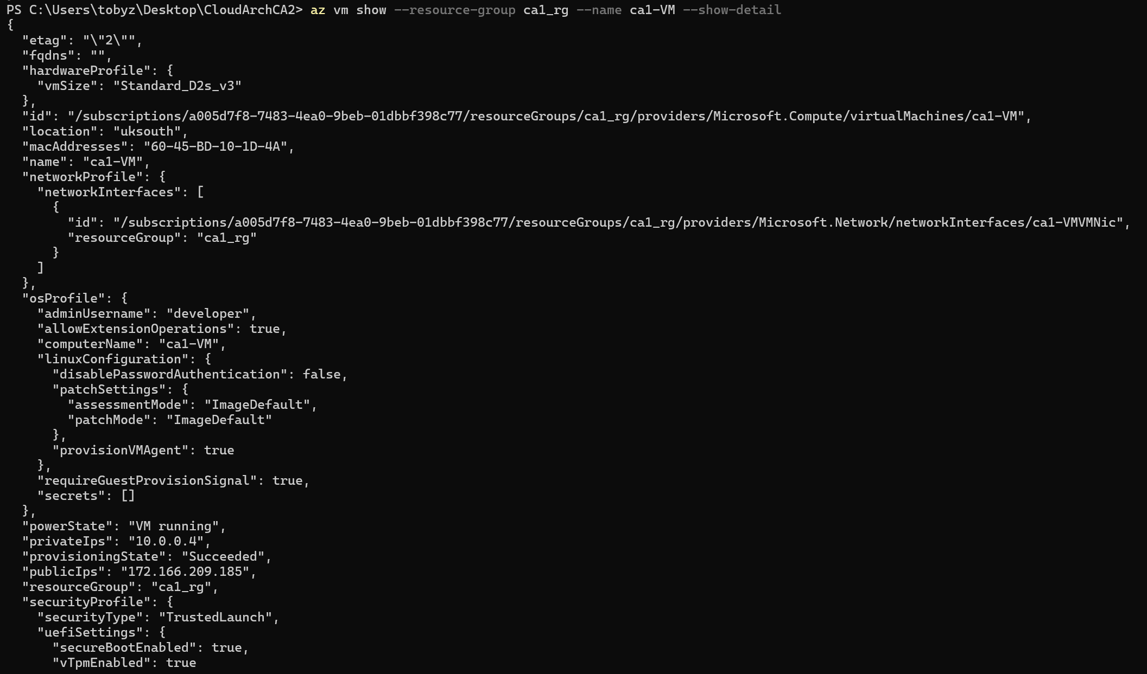
Figure 7 - Checking Existence of Environment

Result shown if you try to run the script again as its already created:
Figure 8 - Result shown from trying to run script again after environment creation

Task 4: Connect to Virtual Machine over SSH

Use command to get the Public Ip Address of Virtual Machine. Copy it with mouse and keep in a secure place for later steps
az vm show -d -g ca1_rg -n ca1-VM --query publicIps -o tsv
Figure 9 - Retrieving Public IP Address of Virtual Machine

Connect to Virtual machine using command:
ssh developer@your-ip-here
Proceed to type yes when you see the question are you sure you want to continue connecting
Enter Password: Developer123@
Connecting to Virtual Machine:
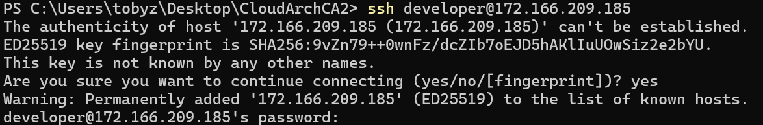
Figure 10 - Connecting to Virtual Machine

What you see once connected:

Figure 11 - Proof of connecting to Virtual Machine
Use command to go out of Virtual Machine:
exit
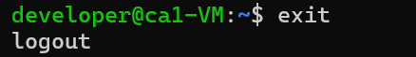
Figure 12 - Exit Virtual Machine

Task 5: Connect to SFTP for transferring jar file to Virtual Machine

Task 5.1: Manually transferring jar file to Virtual Machine

Make sure to unzip Music System folder before doing anything
Use command to get the Public Ip Address of Virtual Machine. Copy it with mouse and keep in a secure place for later steps:
az vm show -d -g ca1_rg -n ca1-VM --query publicIps -o tsv
Figure 13 - Retrieve Virtual Machine IP Address
Connect to SFTP using command:
sftp developer@your-ip-here
Enter Password: Developer123@
Connecting to SFTP: 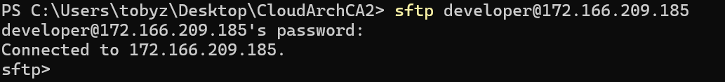
Figure 14 - Connecting to SFTP
Use command to go into target folder in Music System folder:
lcd MovieSystem/MovieSystem/target
Use this command to go into holdJar folder in Virtual Machine:
cd holdJar
Use this command to trandfer jar file from local pc to Virtual Machine:
put MovieSystem-0.0.1-SNAPSHOT.jar
Use this command to exit out of SFTP:
exit
Tranfering jar file from local PC to holdJar folder in Virtual Machine: 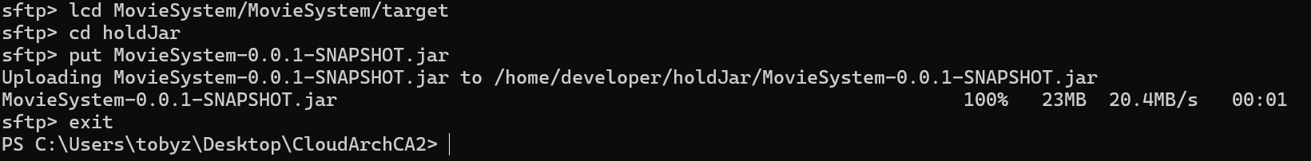
Figure 15 - Transferring jar file from local PC to Virtual Machine

Task 5.2: (Other method) Use bash script to transfer jar file to Virtual Machine
Open jarUpload.sh file and edit it to include IP Address of Virtual Machine, then save the file.
Change to IP Address of Virtual Machine:
Figure 16 - Modify Bash Script file
Open git bash application on PC, use this command to go into project folder with bash script:
Command for if on Desktop:
cd Desktop
cd CloudArchCA2
Command for if on Downloads:
cd Downloads
cd CloudArchCA2
Command to go into Project folder:
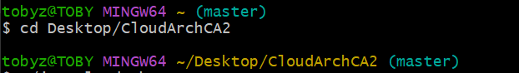
Figure 17 - Command to go into folder

Use command to run bash file:
./jarUpload.sh
Enter password: Developer123@
Command to run bash script:

Figure 18 - Run bash script and enter password
Script executed:
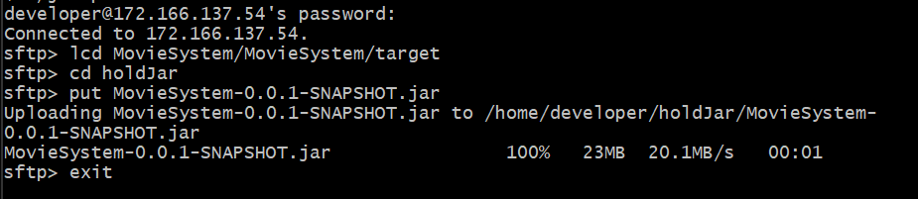
Figure 19 - Script executed

Task 6: Run Jar File on Virtual Machine
Connect back to Virtual Machine if needed
ssh developer@your-ip-here
Password: Developer123@
Use this command into holdJar folder on Virtual Machine that has jarFile:
cd holdJar
Use this command to run jar file on Virtual Machine for Spring Boot Web Application:
java -jar MovieSystem-0.0.1-SNAPSHOT.jar
Spring Boot Application running: 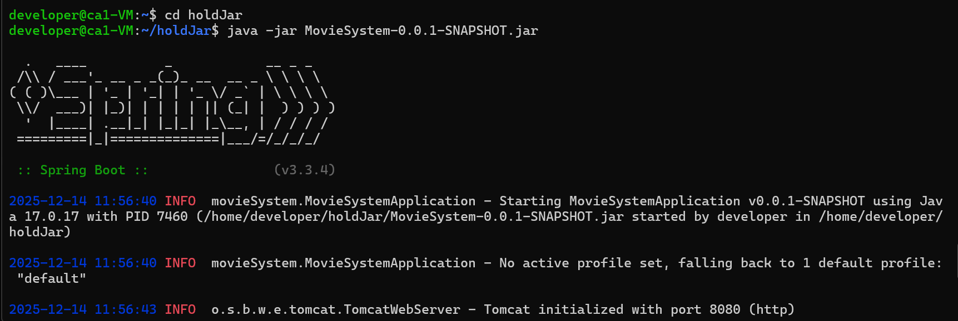
Figure 20 - Spring Boot Application running
If you want to exit and cancel connection use - CTRL + C

Task 6: Access website via Web Browser

Go onto web browser and use this to access website
http://your-ip-here:8080
Note - Use IP Address from before

Website running on Virtual Machine and available for the public on the Web Browser:
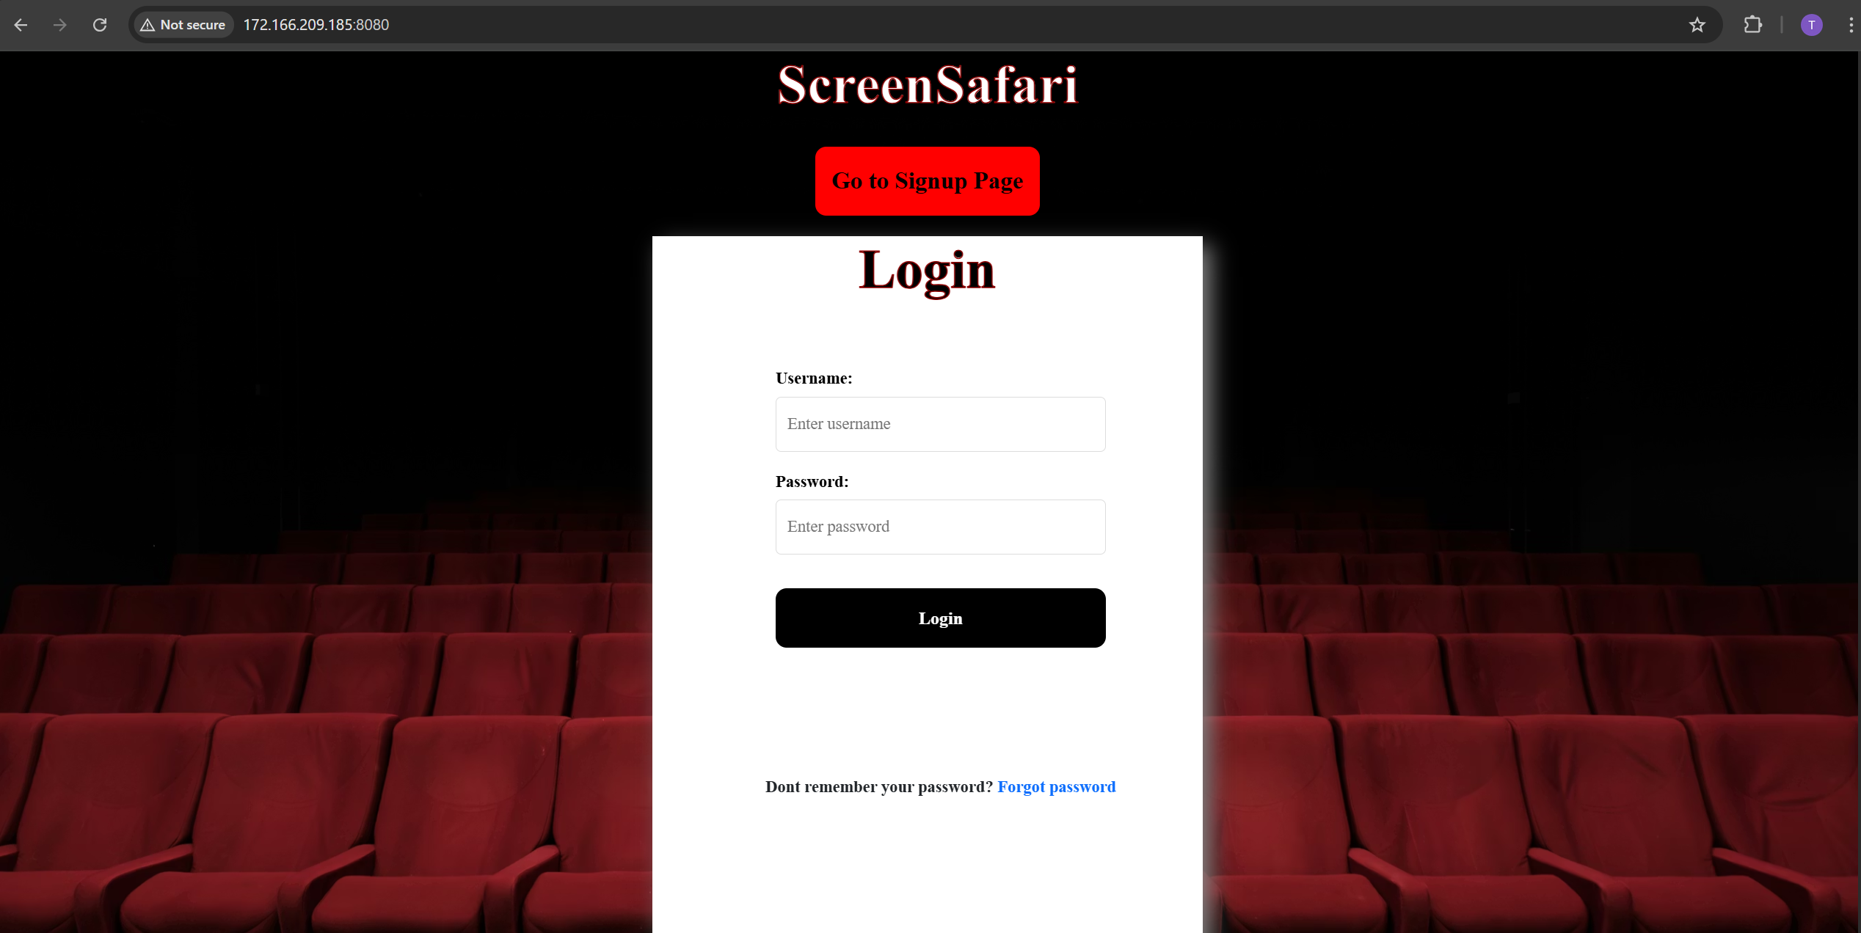
Figure 21 - Website on Web Browser

Login details for website:
Username: admin
Password: Admin123@
Logged into Website:

Figure 22 - Logged into Website

Task 7: Teardown file to remove environment
Use CTRL + C to close Spring Boot Application connection
Use this command to leave virtual machine:
exit
Exiting virtual machine:
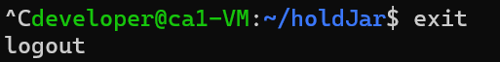
Figure 23 - Close connection and exit virtual machine
Use command to teardown script and remove environment on Azure:
Command entered:
./teardown.ps1
Type y and then enter to proceed with teardown
Results from teardown:
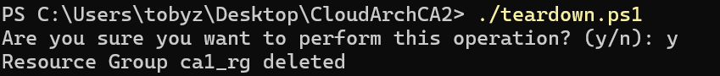
Figure 24 - Teardown Environment

If resource group doesn’t exist to remove environment:
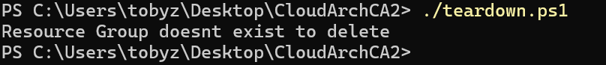
Figure 25 - Resource group doesn’t exist to teardown

